
Lesson 8: Under Pressure
001 Game Creator (Windows only)
VIDEO GAME CREATION
This week: give the enemies you dodge last week actual stakes. An enemy reaching the bottom now costs a life - lose all 3, and "Game Over" appears.
Open your own [YourName]Game project from Lesson 7 - don't start a new one.
Tip: the core exercise needs no new assets - this reuses last week's escape-cleanup code and just gives it a real consequence. For Level 3 sound, use the provided sfx_lifelost.wav and sfx_gameover.wav from the Lesson 8 Assets folder.

Setup
- Open your [YourName]Game project from Lesson 7.
- Create a new Variable (Resources > Variables/Switches/Collections/Tables) named lives, default value 3.

Level 1 - Minimal (MVP)
Every enemy that reaches the bottom unshot now costs the player one life, tracked starting at 3. The moment lives reach zero, "Game Over" appears on screen.
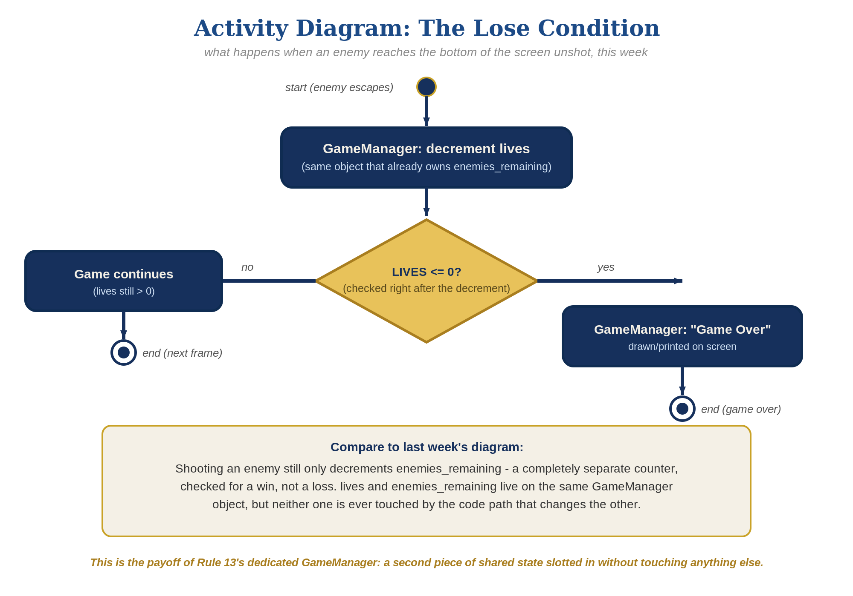
The lose-condition logic behind this week's exercise - the same shape in every engine, whatever the exact code or blocks look like.
- On the enemy Actor Template's existing "Left/Entered Camera" trigger (the Left case, built last week for escape cleanup), add the lives decrement and zero-check BEFORE the existing Destroy event (code below).
- Save, then Play/Test and let all 3 lives run out by letting enemies escape unshot - "Game Over" should appear the instant the third one escapes.
Highlighted lines are new this week; everything else is code you already have.
enemy Actor Trigger: Left/Entered Camera (Left case) -> (revised)
Variable – Modify Value(lives, Subtract, 1)
If(lives <= 0)
Message Box("Game Over")
Actor – Destroy/Revive Actor(this, Destroy)

Level 2 - Complete (Alpha/Beta)
Shooting an enemy never costs a life, and letting one escape never counts as a kill - the two counters stay completely independent.
- Shoot an enemy and confirm lives does NOT change - only the "Collided with actor" trigger, and enemies_remaining, should be involved.
- Let an enemy escape and confirm enemies_remaining does NOT change - only the "Left/Entered Camera" trigger, and lives, should be involved.
- Confirm "Game Over" appears exactly once, exactly when lives reaches zero.

Level 3 - Refined (Ready to Publish) - pick any that interest you
- Visual: add a Text/HUD display element showing the current lives value, updated inside the "Left/Entered Camera" trigger - a nice touch, though the full scoreboard-style UI is coming properly in Lesson 9.
- Sound: import the provided sfx_lifelost.wav and sfx_gameover.wav, then add a "Play Sound" event to the "Left/Entered Camera" trigger's script - sfx_lifelost.wav on each escape, sfx_gameover.wav instead right before the Message Box when lives reaches zero.
- Structure: the enemy Template now has exactly two Triggers, each doing one clear job - "Collided with actor" (a kill, changes enemies_remaining) and "Left/Entered Camera" (an escape, changes lives). Neither one references the other's variable. (Unlike Scratch/Godot/GameMaker/Unreal, 001 Game Creator's Actor Triggers are bound to the actor they're attached to, so lives stays on the enemy Template itself rather than moving to a separate "GameManager" Actor - the same documented exception enemies_remaining already relies on since Lesson 6.)

If Something's Wrong
- Lives decreases when you shoot an enemy: confirm the lives decrement is only in "Left/Entered Camera," not accidentally added to "Collided with actor" too.
- "Game Over" never appears: confirm lives actually starts at 3 (check the Variable's default value) and that "Left/Entered Camera" is actually firing for the Left case, not Entered.
- "Game Over" and "You Win!" Message Boxes both pop up oddly: this can happen if an enemy escapes at the same moment as the last enemy is shot - not a bug, just an edge case worth a quick laugh with students if it comes up.

Want More?
001gamecreator.com/wiki, Student Resource List > 001 Game Creator

